**Introduction**

***1.1 Overview***

Air Transportation Network Dataset is a comprehensive collection of information on airports, airlines and their routes. It contains information such as names, cities, countries, codes (IATA and ICAO) longitudes, latitudes and altitudes of airports across the world with detailed time zone and daylight saving time data. Additionally, this includes information about airlines including their IDs, name aliases, IATA and ICAO codes, callsigns country of origin and active/inactive status. Similarly, it also covers route details such as airline sources to destination airports along with essential details like codeshare stakeholder if any stops required during this journey along with the type of aircraft being used for that particular journey.

***1.2 Purpose***

Aiming to improve the efficiency, safety, and sustainability of the global air transportation network while addressing various economic, environmental, and social challenges. To analyze connectivity, flight routes, passenger traffic, cargo movement, patterns and trends,To improve the efficiency, and sustainability of air travel by optimizing routes, scheduling, and resource allocation.

**Problem Definition & Design Thinking**

***2.1 Empathy Map***

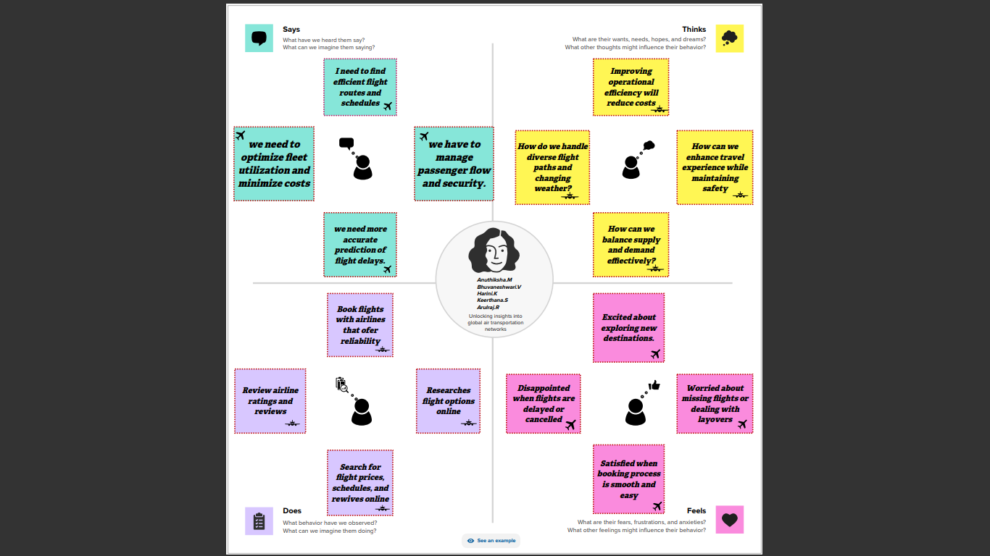

***2.2 Ideation & Brainstorming Map***

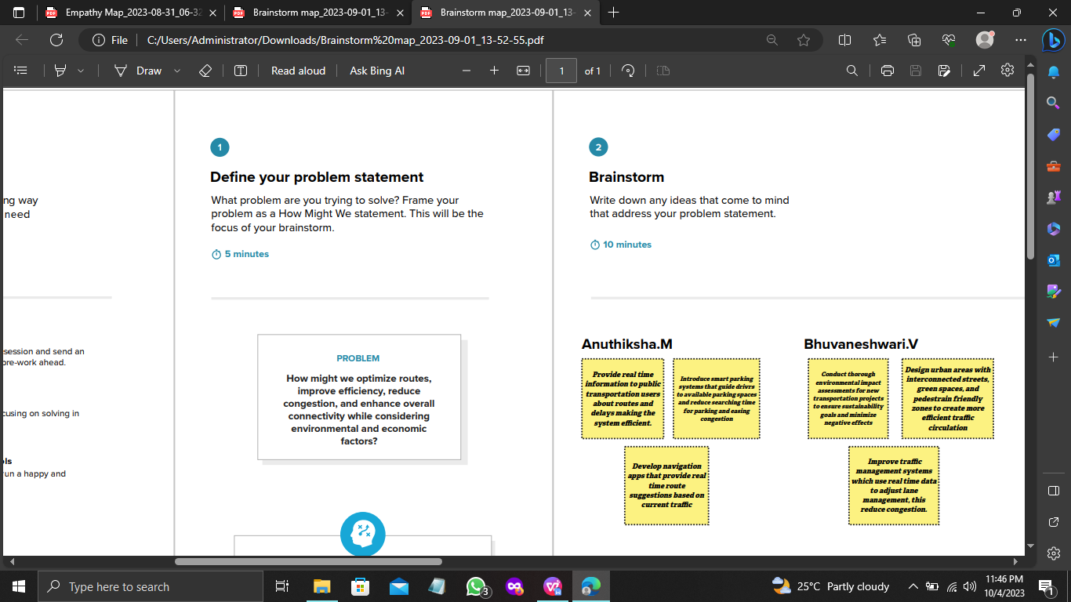

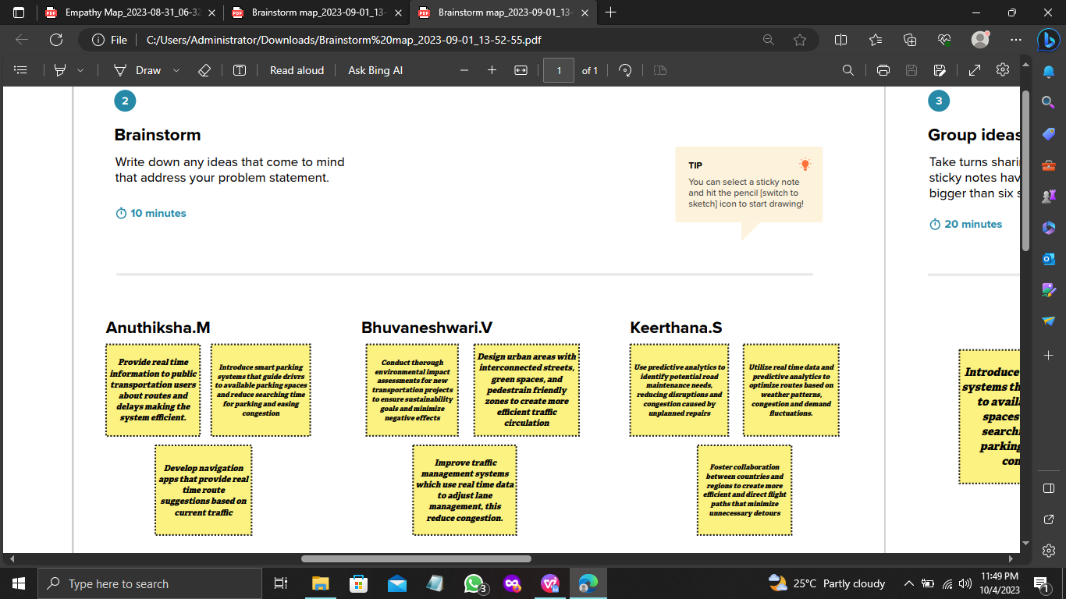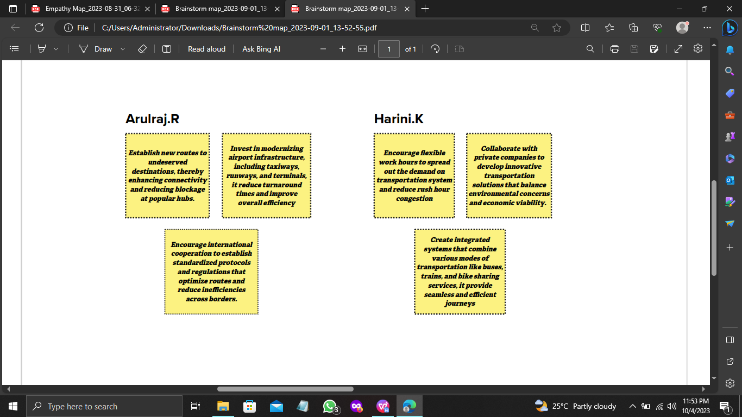

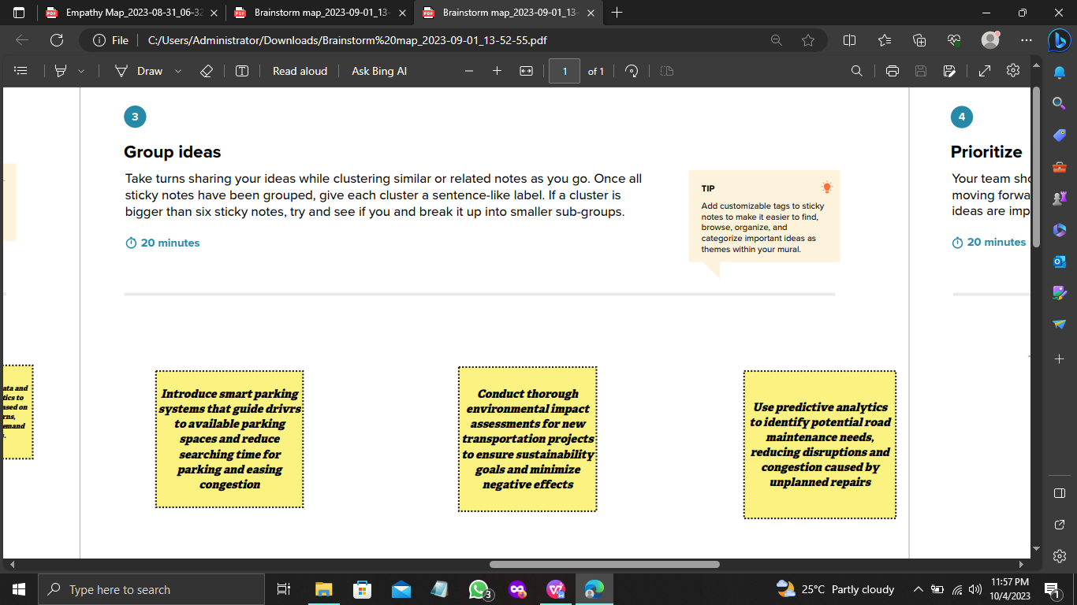

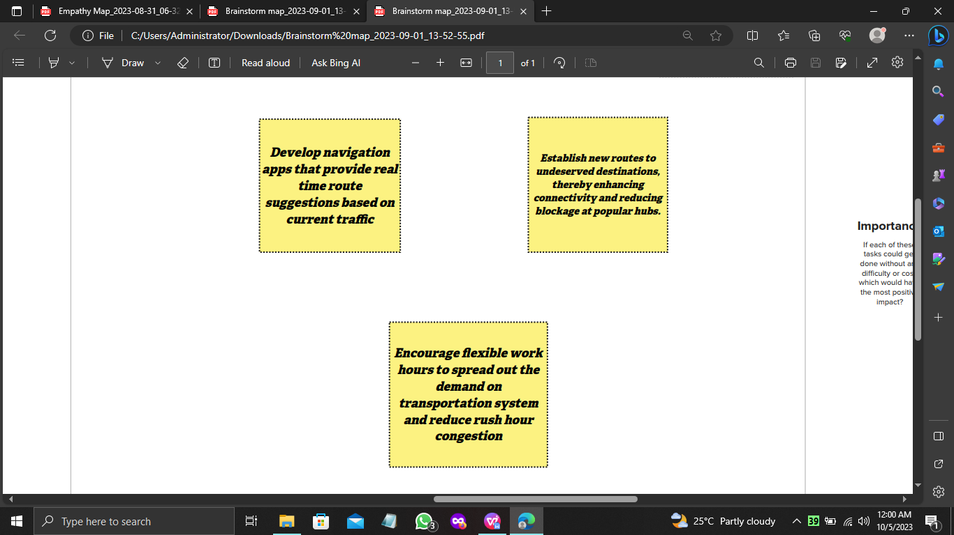

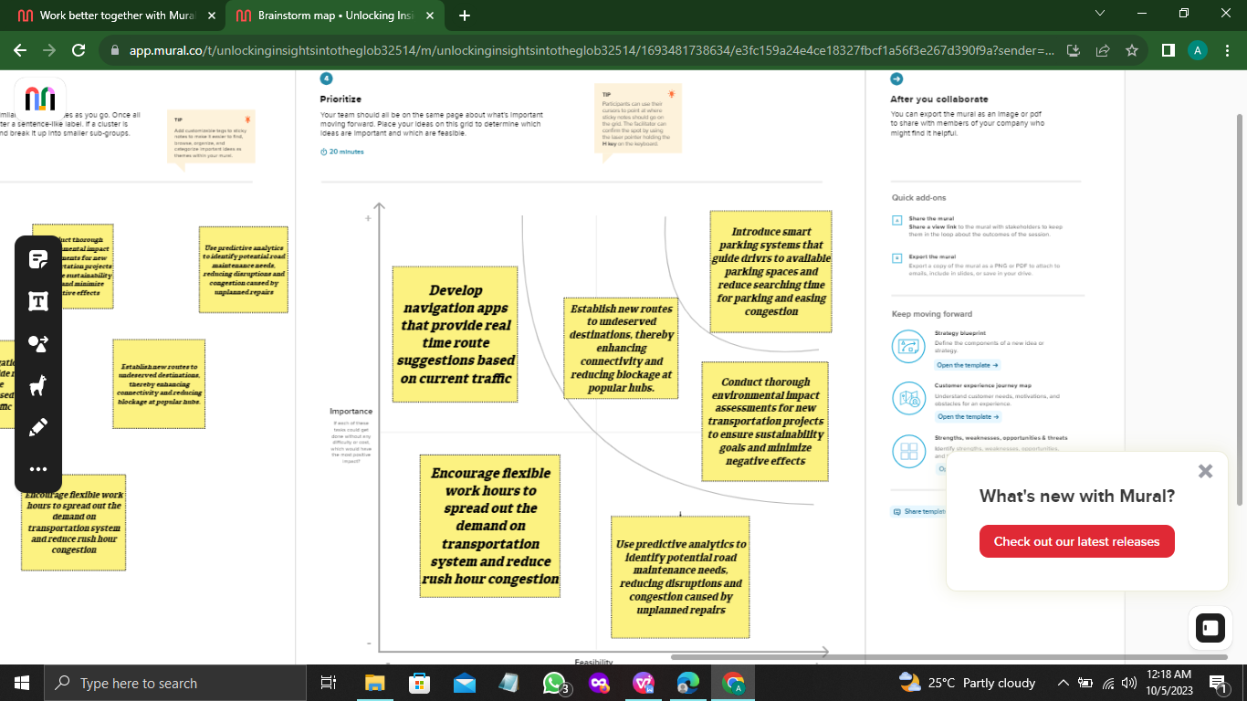

**Result**

***Dashboard***

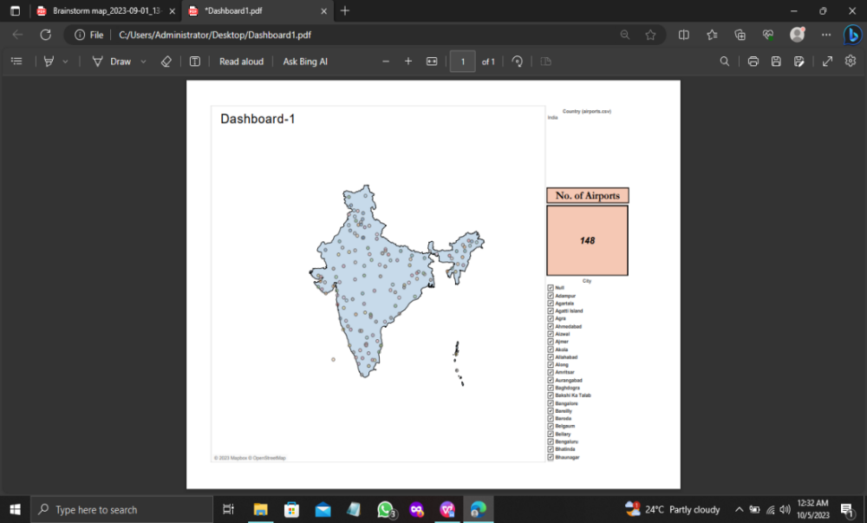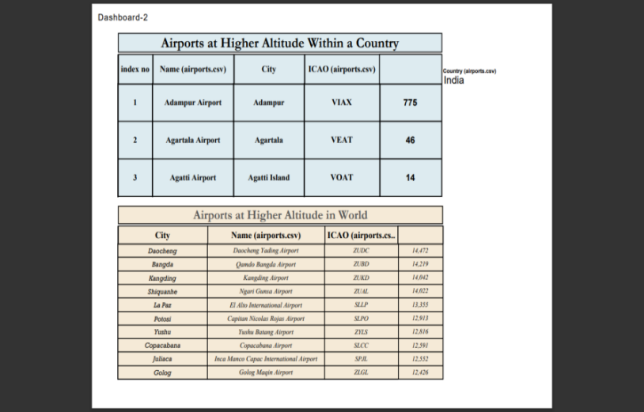

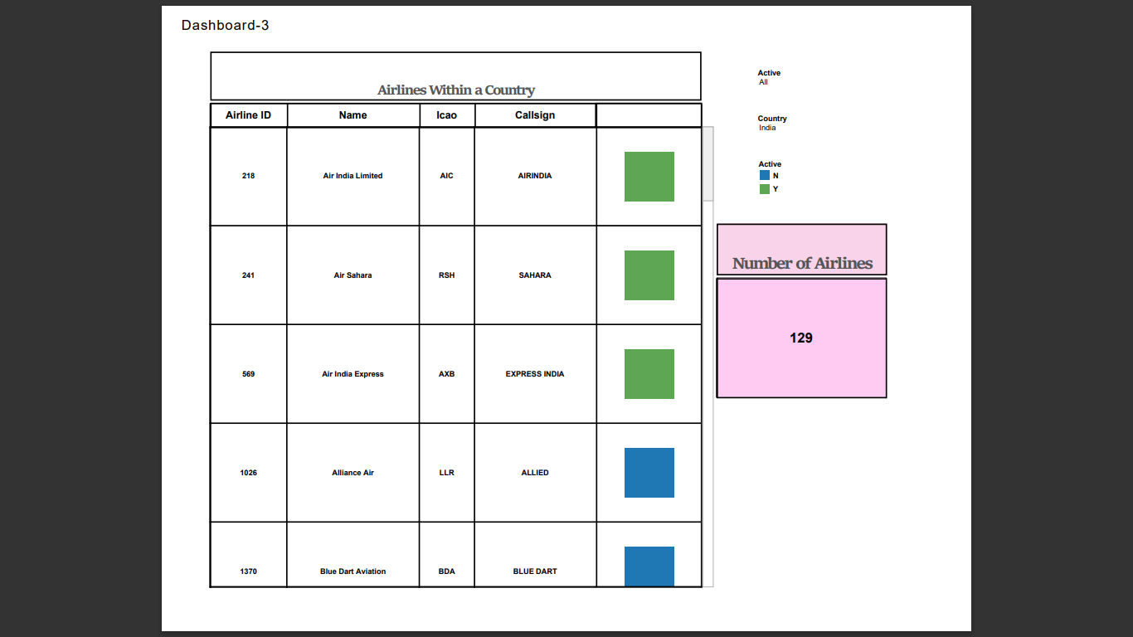

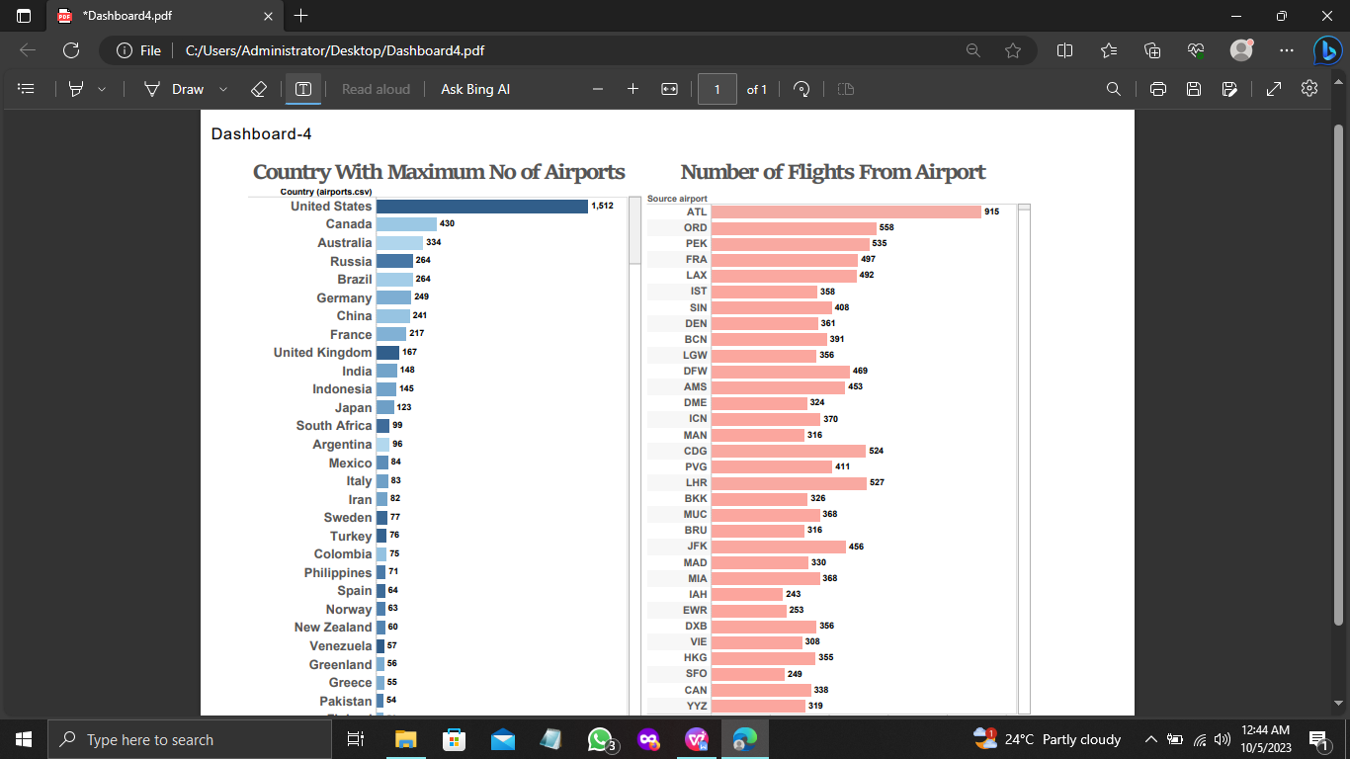

***Story***

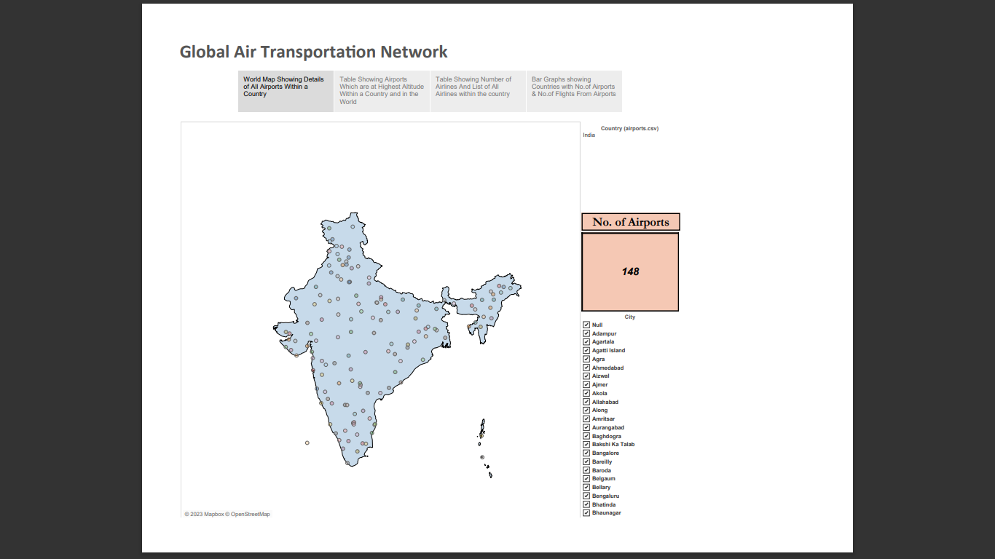

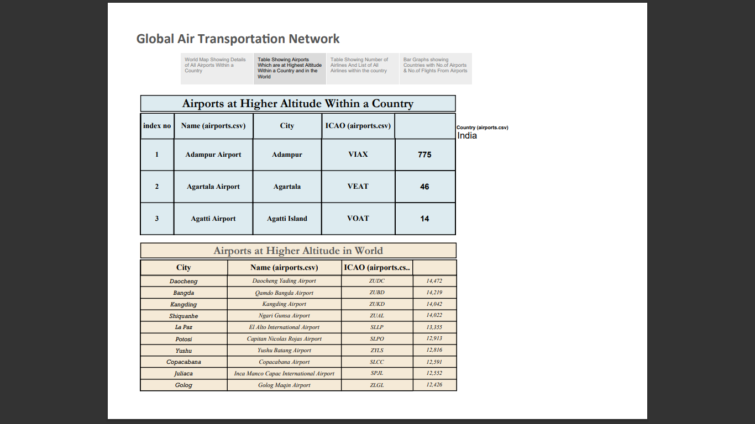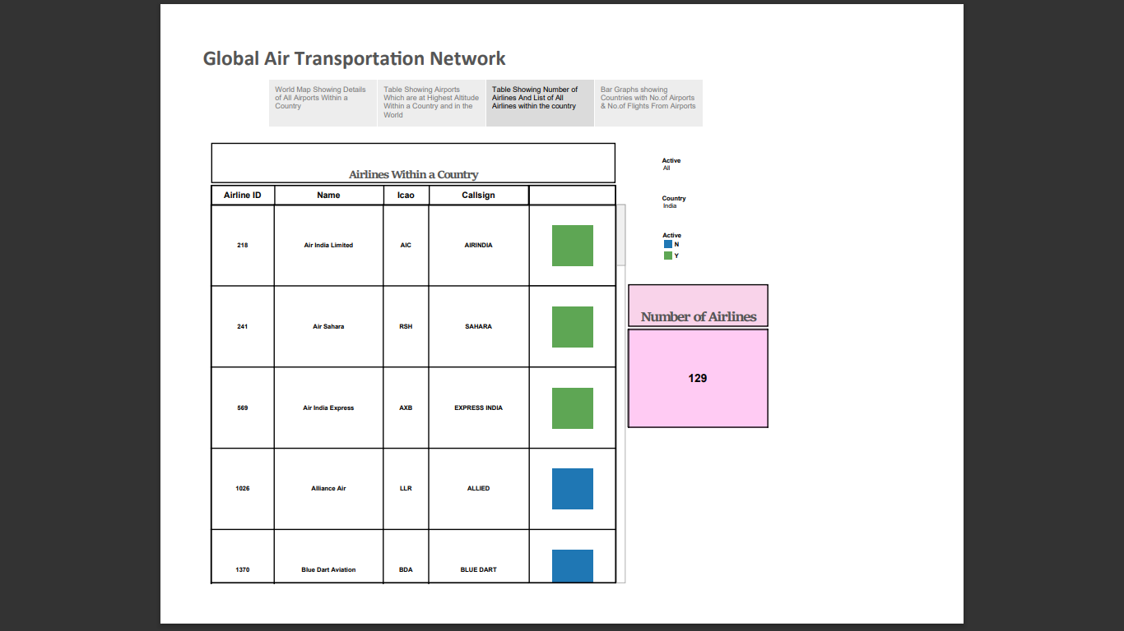

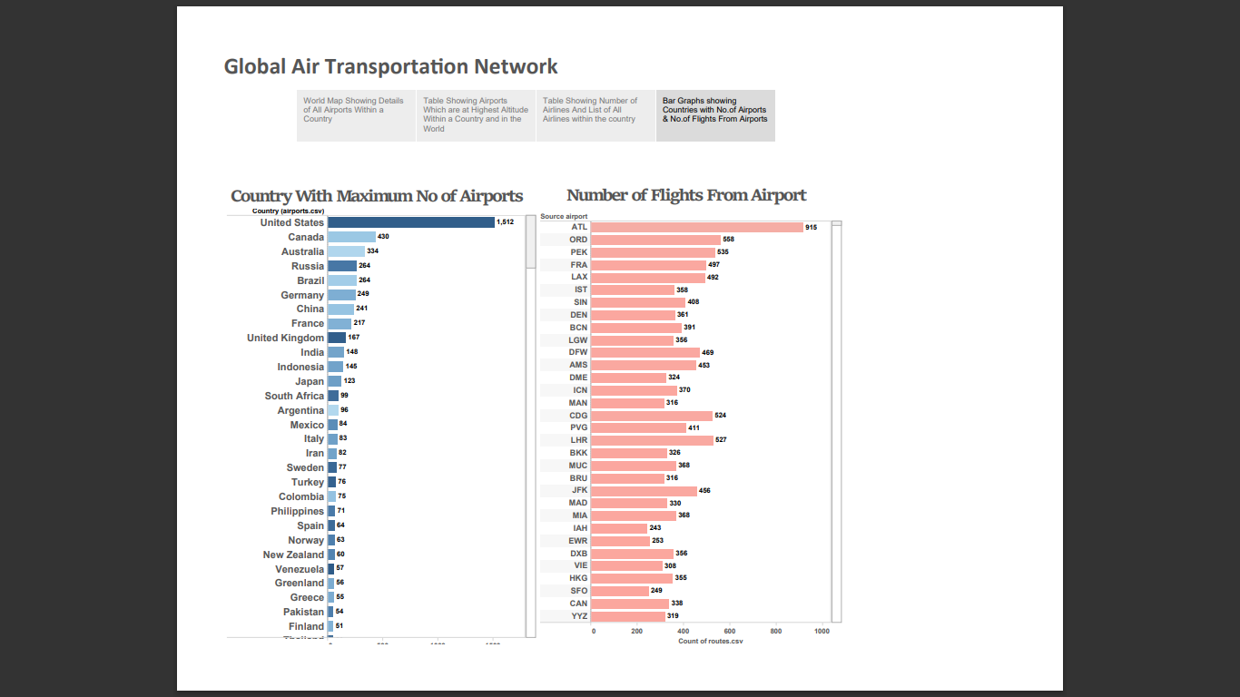

**Advantages & Disadvantages**

***Advantages:***

* It helps airlines, airport authorities, tourism boards, and government agencies to identify new business opportunities, optimize capacity planning, and streamline operations.

* By providing stakeholders with a comprehensive understanding of the air transportation network, It helps to optimize routes and reduce congestion in the air, leading to improved air quality and reduced carbon emissions.

* This can contribute to the overall well-being of communities around the world, by making air travel more accessible, affordable, and eco-friendly.

# *Disadvantages:*

* Gathering and analyzing data on air travel may raise privacy issues related to passenger information.
* Collecting and processing large volumes of data can be expensive and require significant resources.
* Handling sensitive aviation data may pose security risks if not properly safeguarded.

**Applications**

* Identifying optimal flight routes and schedules to improve efficiency and reduce fuel consumption.
* Determining how airports can expand or adapt infrastructure to accommodate increasing passenger and cargo volumes.
* Assisting airlines in making informed decisions about route expansions, fleet management, and pricing strategies.
* Enhancing the passenger experience by analyzing traveler preferences, improving airport services, and reducing wait times.
* Identifying vulnerabilities in the network to enhance safety measures and minimize security risks.
* Developing strategies to reduce the environmental impact of air travel, such as promoting fuel-efficient aircraft and sustainable practices.

**Conclusion**

From optimizing routes and enhancing safety to fostering economic growth and sustainability, the insights gleaned from this project can shape the future of aviation. However, it is essential to navigate the project's potential disadvantages, such as data privacy concerns and ethical considerations, with diligence and responsibility. As the world continues to evolve, understanding the dynamics of the global air transportation network remains paramount. This project serves as a crucial step in harnessing the power of data to propel the aviation industry forward, making travel safer, more efficient, and environmentally sustainable for generations to come.

**Future Scope**

* Implementing advanced AI and predictive analytics for forecasting trends and challenges.
* Expanding analysis to better understand and mitigate the environmental impact of air travel.

* Creating digital twins of airports and flight routes for simulation and optimization.
* Integrating air travel with other transportation modes for seamless multi-modal journeys.
* Utilizing data to improve the end-to-end passenger experience.